**OWIN**

* It is specification the describes how you abstract away a web server in very efficient way
* Thus web app doesn’t care about its hosted and focus the business problems

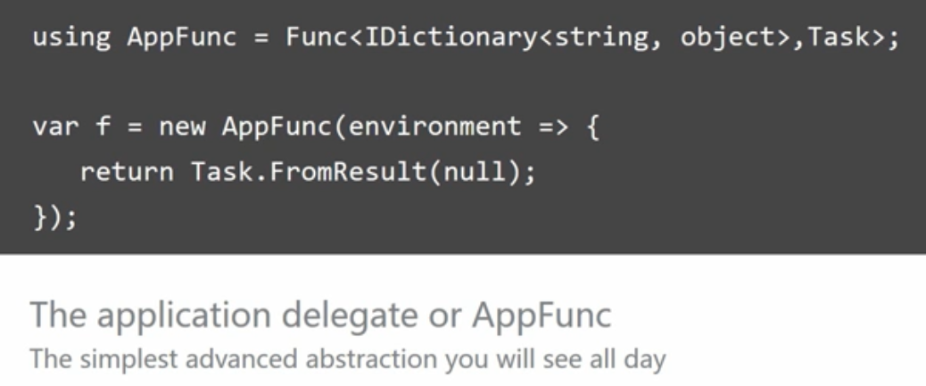

* Owin Parts or Actors
  + - Host
    - Server
    - Middleware
    - Application
* Host : It is process of sort that host the other parts . It can be IIS, console App or window service. It is responsible for starting everything up
* Server: Responsible for accepting incoming request and outputting outgoing request. In case IIS , host and server are same
* Middleware: It is piece of code that sits between server and app. Request and response pass through them. They could be used to inspect and modify incoming request and outgoing response
* App : your business code , responsible for creating actual response

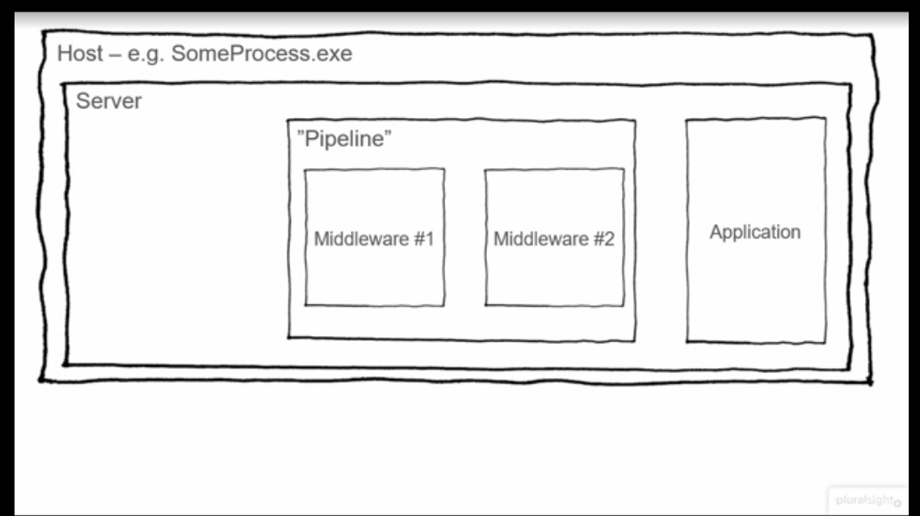

* Since pipeline is rural to interact with middleware . we combine it with web application to make web framework

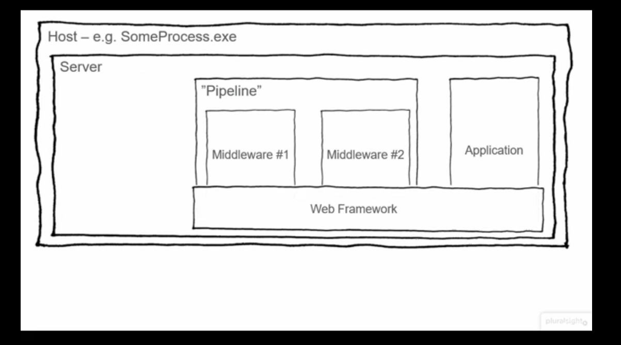

* In the realm of OWIN, Web framework is set of self-contained OWIN middleware that are plugged into the OWIN pipeline, which exposes a set of apis for the developer to interact with

**OWIN Flow :**

* Server receives a request
* Server breaks down the request info into a set of pre defined keys and objects
* Request pass through each middleware and waits on it to complete
* Finally reach the application
* App generates the response , once its start writing to the response stream. Response header are sent back. (response header can’t be changes after this )
* Response pass through the middleware
* Finally response is sent back to the client by the server

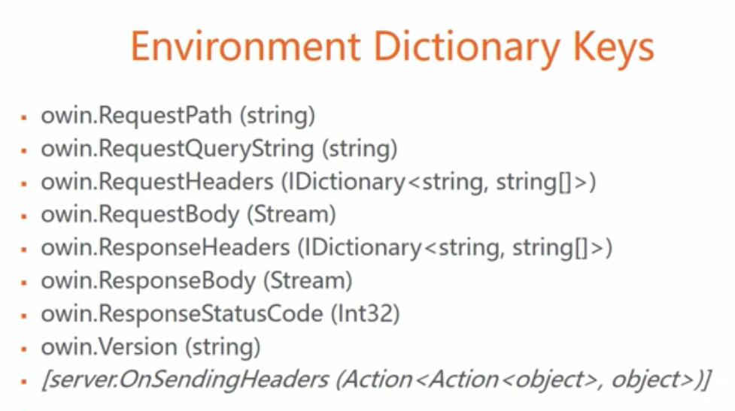

**Project Katana:**

Open source Microsoft implementation of OWIN specification

Advantages of OWIN :

* Self-hosting
* Easier to add new middlewares
* Short-circuiting between middlewares
* Middleware options are defined because it will help us execute middleware actions based on any condition we want. Eg based on the request request coming from which server we can determine to do specific check or not
* Convention by which we add a middleware in project katana is “app.use<name of the middleware>

**ToDo:**

Create middleware after watching the video for web api

Create “use middleware” method

Reference

<https://github.com/domaindrivendev/Swashbuckle>

<https://www.youtube.com/watch?v=9h2tlxrPPyc&vl=en>

<https://github.com/ninject/Ninject.Web.Common/wiki/Setting-up-a-OWIN-WebApi-application>

<https://docs.microsoft.com/en-us/aspnet/web-api/overview/hosting-aspnet-web-api/use-owin-to-self-host-web-api>